A Bicycle Ride Honoring Henry Ar Foon
Curated by New England Coalition for Cycling Diversity
Diversity, Equity and Inclusion on a Bike

Hosted by Blue Hills Cycling Club

· Come join us on a ride through scenic Hull, Cohasset, Hingham and Scituate. We ride in honor of Chinese American cyclist Henry Ar Foon, elected president of the Winnisimmet Cycle Club of Chelsea in 1897. We will visit his later-in-life home site and his grave site in North Scituate.
· 9am, October 10th, 2021
· Start at Wompatuck State Park Visitor's Center 204 Union St., Hingham https://www.mass.gov/locations/wompatuck-state-park/
· This is a free group ride.
· Sign waiver on the day of the ride.
· Ride leaders and sweepers TBA
· Multiple-speed, no-drop groups to accommodate newer riders, as well as those who like more spirited rides. Maps and RideWith GPS directions will be provided.

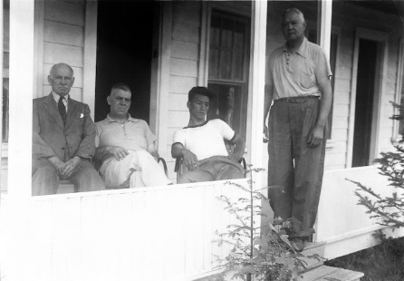 | 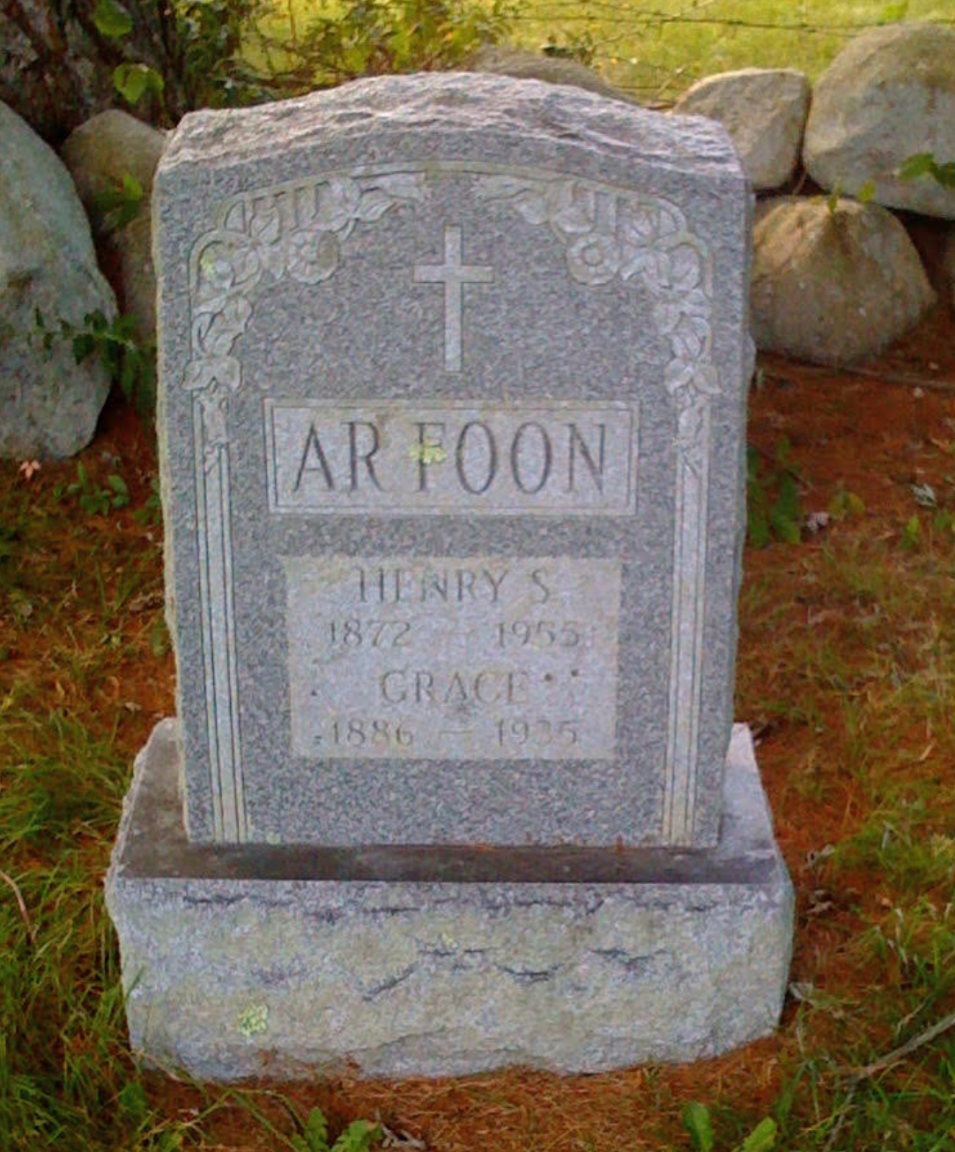
Cyclist Henry Ar Foon (1872-1955) , first Chinese boy born in the Boston area. With friends at his home 60 Mordecai Lincoln Road, Scituate.  Mr. McKinney, Bill Barnes, Eddie ArTick, Henry ArFoon | Henry and Grace Ar Foon gravesite in Mount Hope Cemetery, Scituate, near corner Mt. Hope Lane and next to 330 Clapp Road.
Photos courtesy Polly Kimmitt. https://pk-pollyblog.blogspot.com/2013/09/the-ar-foon-family-of-chelsea-and.html

